Sales Representative CRUD and Login Process:

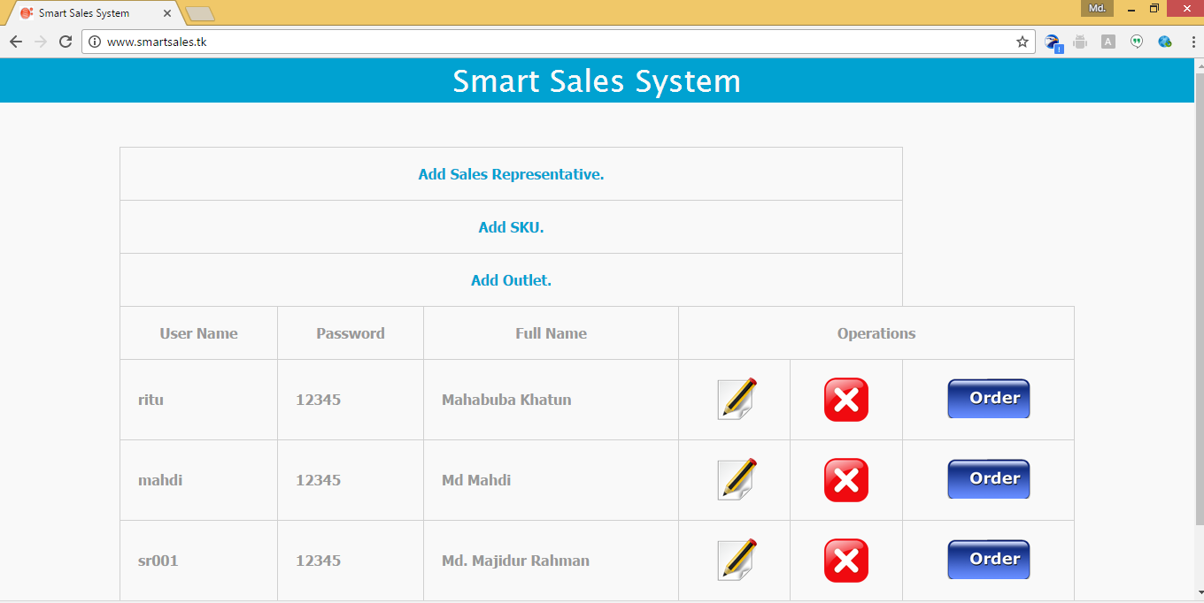

Add Sales Representative Here

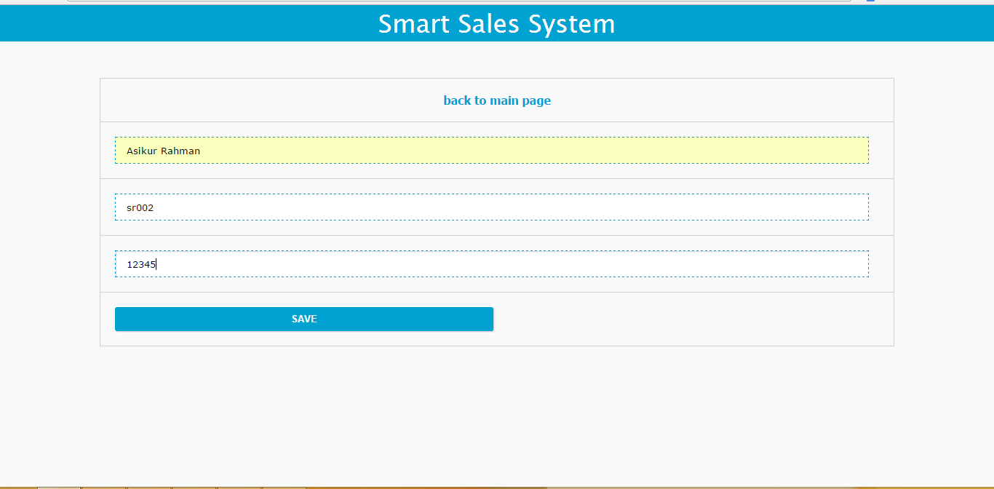

Save Sales Representative

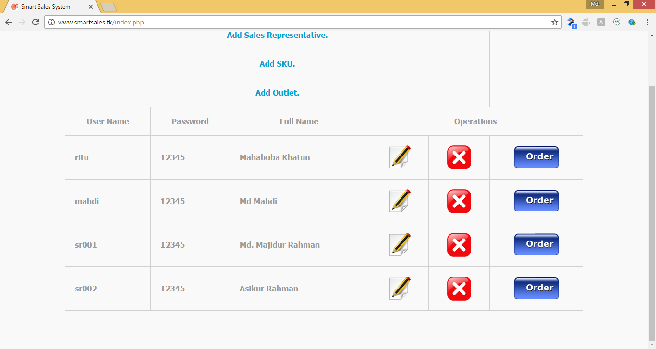

Update Sales Representative Information

Type User Name and password click then on Login

View Sales Representative Sales Report

Delete Sales Representative

Sales Representative Information

